BLOG STARTER PAGE DEPLOYMENT
Step-by-step Git, GitHub and GitHub Pages practical guide
Important note about the screenshots: The images in this guide are illustrative process screenshots created to show what each step should look like. They are not captures from your GitHub account, and no repository has been created or deployed on your behalf. Replace YOUR-USERNAME with your GitHub username and insert your real repository and live-site URLs before submission.

1. Task objective
Create a Git repository containing an HTML file named blog.html, add a blog title and sample post preview, commit the work with clear messages, push it to GitHub, publish it using GitHub Pages, and later update the page with a second post preview and push again.

2. Create the local project
Open Terminal (macOS/Linux) or Git Bash (Windows), then run:
mkdir blog-starter
cd blog-starter
git init
touch blog.html
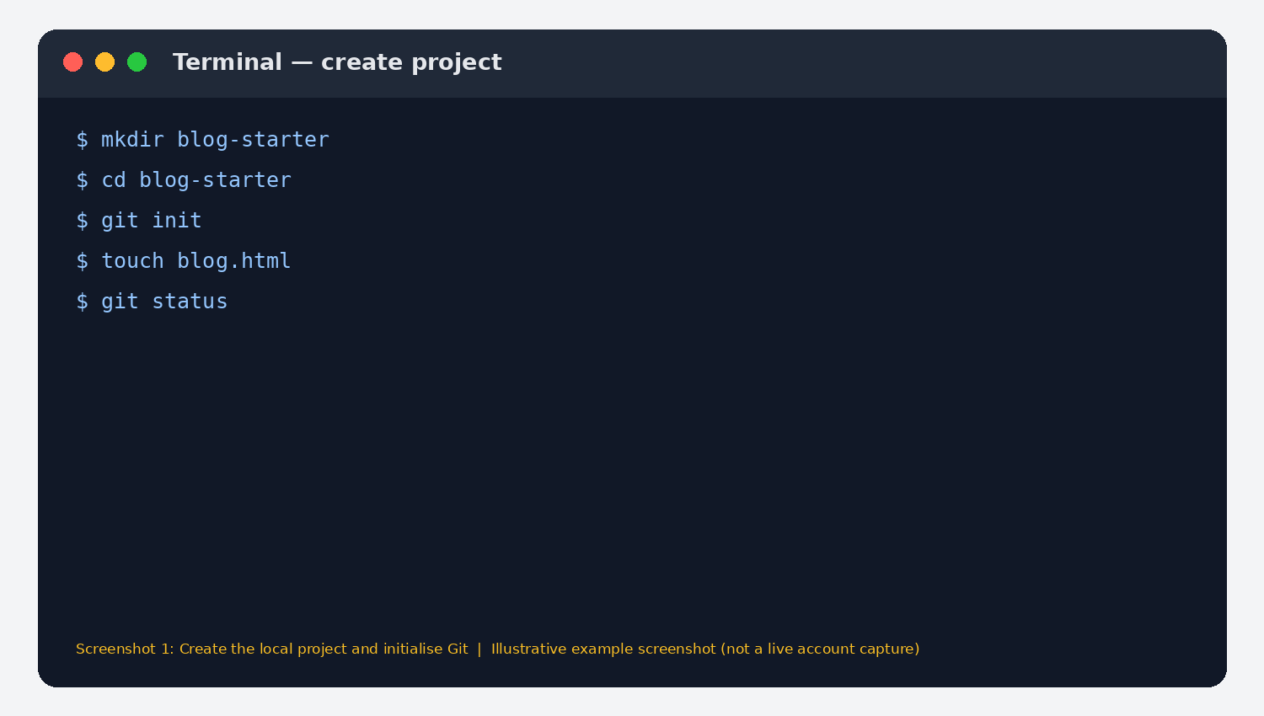
Figure 1. Illustrative terminal view of creating the folder and initialising Git.

3. Create blog.html
Open blog.html in a code editor and paste the following starter page. Save the file.
<!DOCTYPE html>
<html lang="en">
<head>
<meta charset="UTF-8">
<meta name="viewport" content="width=device-width, initial-scale=1.0">
<title>The Byte-Sized Blog</title>
<style>
body { font-family: Arial, sans-serif; margin: 0; background: #f5f7fb; color: #172033; }
header { background: #0b1f4b; color: white; padding: 28px 8%; }
main { max-width: 900px; margin: 40px auto; padding: 0 20px; }
article { background: white; padding: 24px; margin: 18px 0; border-radius: 10px; }
a { color: #2459a6; }
</style>
</head>
<body>
<header><h1>The Byte-Sized Blog</h1><p>Ideas, notes &amp; practical guides</p></header>
<main>
<h2>Latest posts</h2>
<article>
<h3>Getting started with Git</h3>
<p>A quick introduction to version control, repositories, commits and pushes.</p>
<a href="#">Read more</a>
</article>
</main>
</body>
</html>
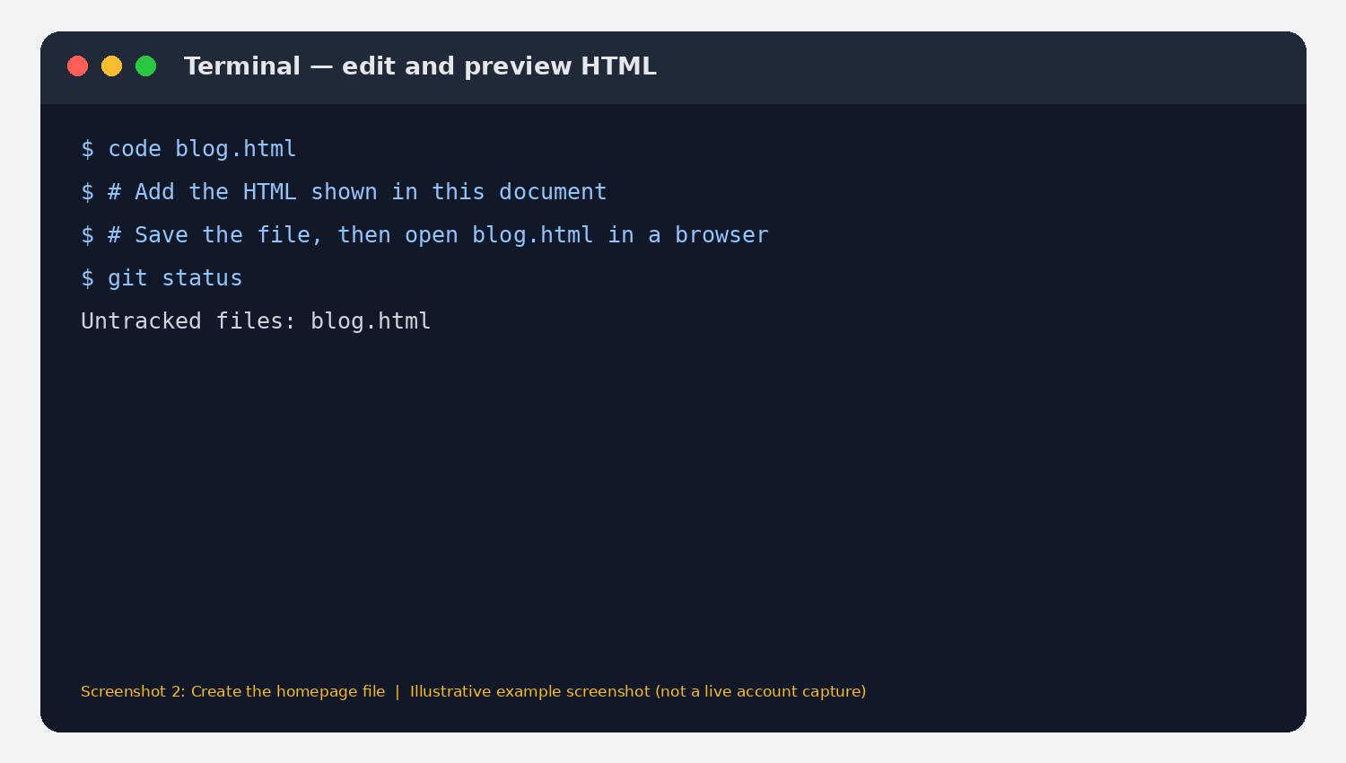
Figure 2. Illustrative editor/terminal workflow for creating the HTML file.

4. Commit the first version
Run these commands from inside the blog-starter folder:
git add blog.html
git commit -m "Add blog starter homepage"
git branch -M main
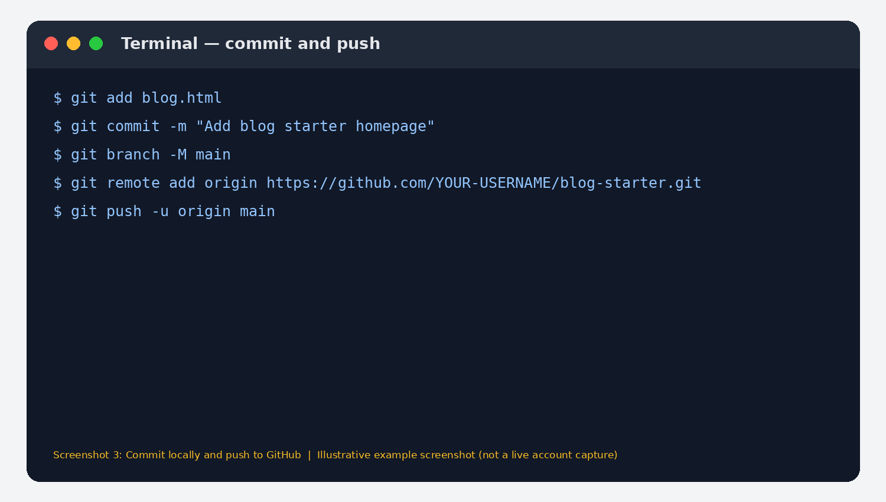
Figure 3. Illustrative terminal commands for staging and committing the first version.

5. Create a GitHub repository and push
On GitHub, sign in and create a new repository named blog-starter. Choose Public if you want the simplest GitHub Pages setup for this exercise. Do not initialise it with a README if you already created files locally. Copy the repository HTTPS URL, then run the following command using your actual username:
git remote add origin https://github.com/YOUR-USERNAME/blog-starter.git\ngit push -u origin main
If Git reports that origin already exists, use: git remote set-url origin https://github.com/YOUR-USERNAME/blog-starter.git
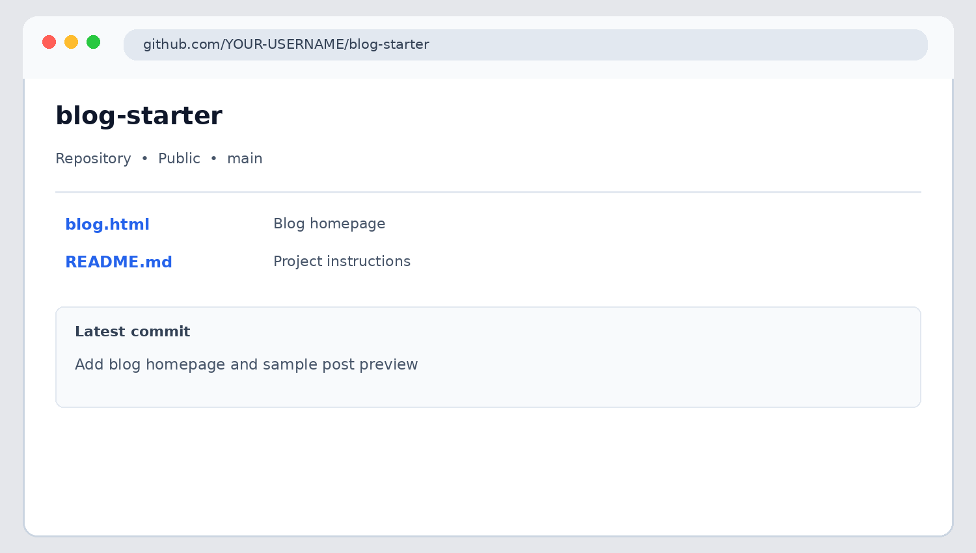
Figure 4. Illustrative view of the GitHub repository and blog.html file.

6. Publish with GitHub Pages
In the repository, open Settings → Pages. Under Build and deployment, select Deploy from a branch. Choose branch main and folder /(root), then click Save. Wait for the deployment to complete. GitHub Pages will show the published website URL in the Pages settings.
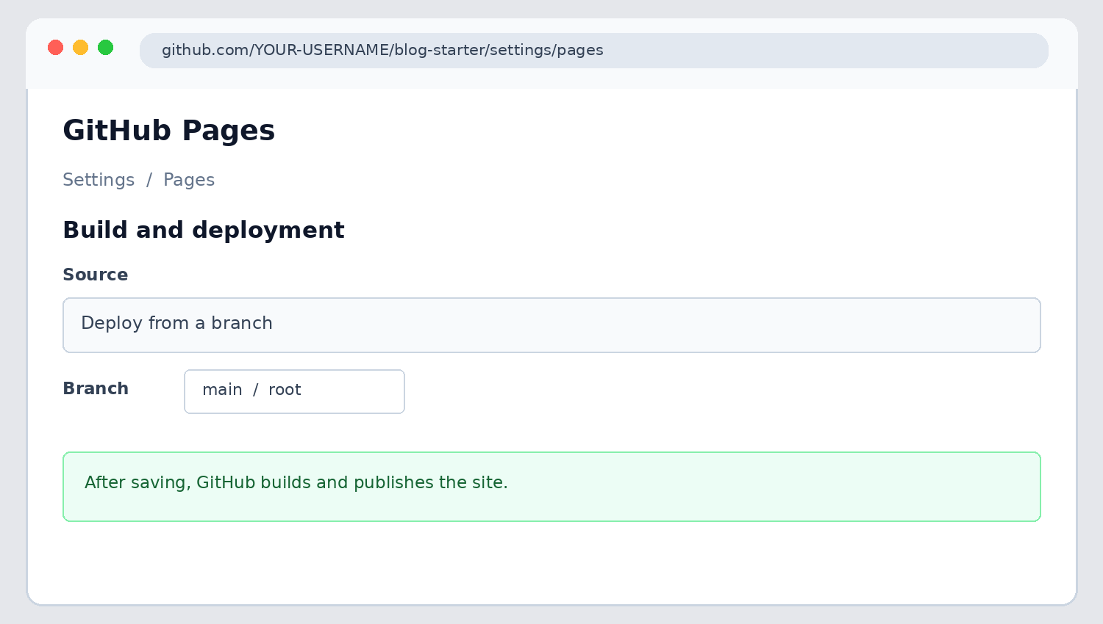
Figure 5. Illustrative GitHub Pages settings. Select main and /(root).
For a project repository named blog-starter, the usual site URL format is:
https://YOUR-USERNAME.github.io/blog-starter/
Important: because the task specifically names the file blog.html, its direct page URL will normally be https://YOUR-USERNAME.github.io/blog-starter/blog.html. The shorter project-site URL https://YOUR-USERNAME.github.io/blog-starter/ requires an index.html homepage. You can keep blog.html for the task and also create an index.html copy (or rename it to index.html) if you want the site root to open the blog automatically. Use the exact URL shown/tested in your own deployment.

7. Check the published homepage
Open the live URL shown by GitHub Pages. Confirm that the blog title and first sample post preview appear correctly.
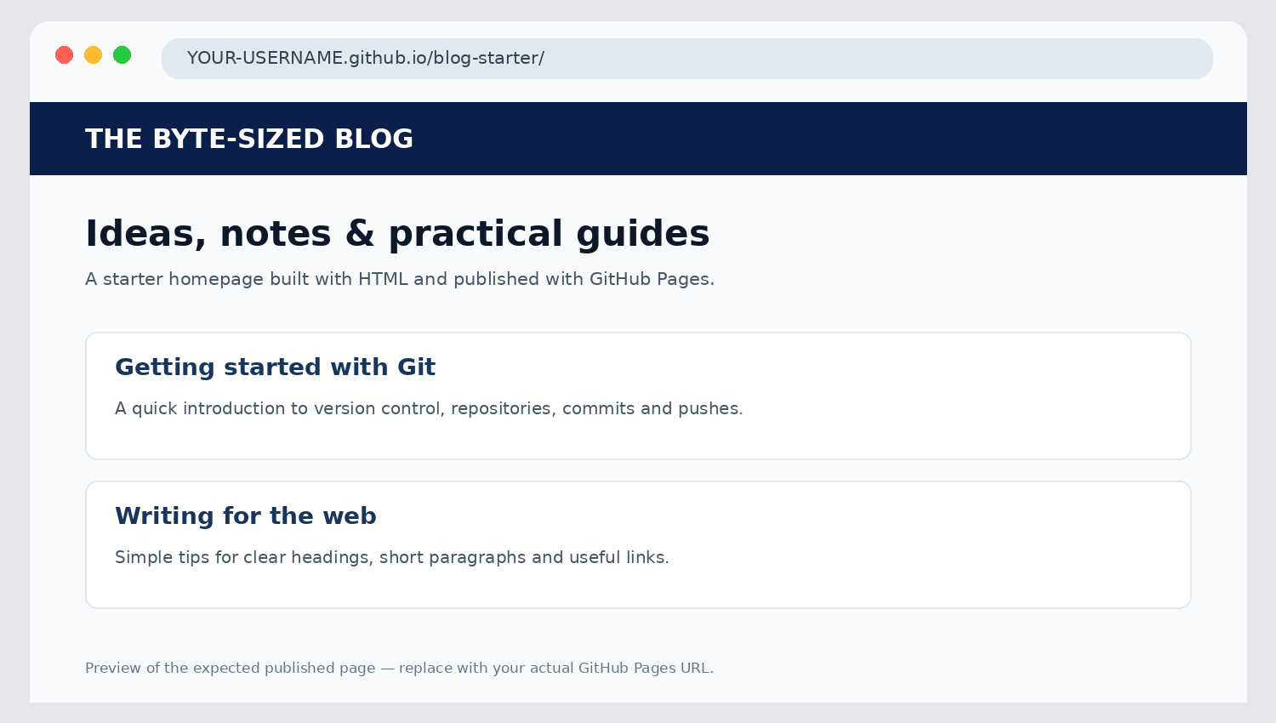
Figure 6. Illustrative preview of the expected published blog homepage.

8. Add a second post preview and push again
Edit blog.html and add another article block inside the <main> element, below the first article:
<article>
<h3>Writing for the web</h3>
<p>Simple tips for clear headings, short paragraphs and useful links.</p>
<a href="#">Read more</a>
</article>
Save the file and run:
git add blog.html
git commit -m "Add second blog post preview"
git push
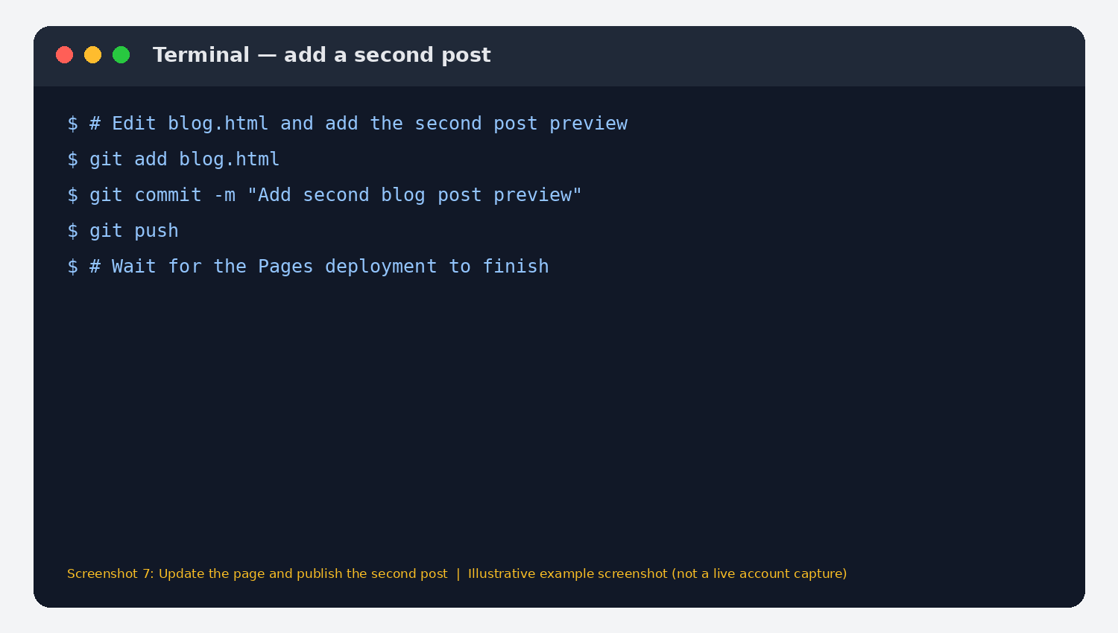
Figure 7. Illustrative terminal commands for the second update.
Wait for GitHub Pages to finish rebuilding, then refresh the live website and verify that both post previews are visible.

9. Commands used — quick reference
Purpose | Command
Create folder | mkdir blog-starter
Enter folder | cd blog-starter
Initialise Git | git init
Stage file | git add blog.html
Commit first version | git commit -m "Add blog starter homepage"
Set default branch | git branch -M main
Connect GitHub remote | git remote add origin https://github.com/YOUR-USERNAME/blog-starter.git
Push first version | git push -u origin main
Stage later change | git add blog.html
Commit later change | git commit -m "Add second blog post preview"
Push later change | git push

10. Troubleshooting
- Pages URL shows 404: confirm Pages is enabled, branch is main, folder is /(root), and the file is named exactly blog.html. For a project site, the default landing page should normally be named index.html. To make the blog homepage open directly at the root URL, rename blog.html to index.html or add an index.html copy, then commit and push.
- Push is rejected: run git pull --rebase origin main if the remote repository already contains an initial commit, resolve any conflicts, then push again.
- Changes are not visible: check the Actions tab for the Pages deployment status, wait for it to finish, and hard-refresh the browser.

